**Creating Restful Webservice**

Step 1: Create a New Java Web Application Project

1. Open NetBeans IDE.
2. Click on "File" > "New Project..."
3. Choose "Java Web" > "Web Application" and click "Next."

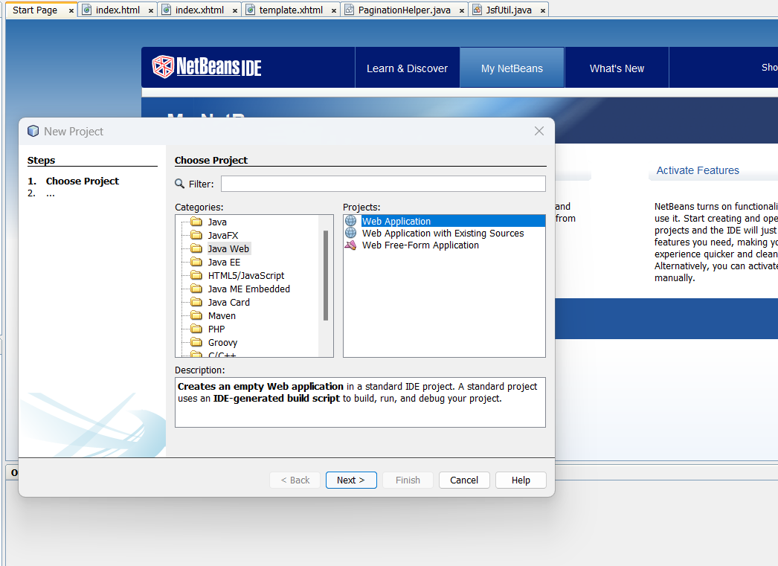

1. Give your project a name (e.g., "RestfulWebServicePrac") and choose a location. Click "Next."

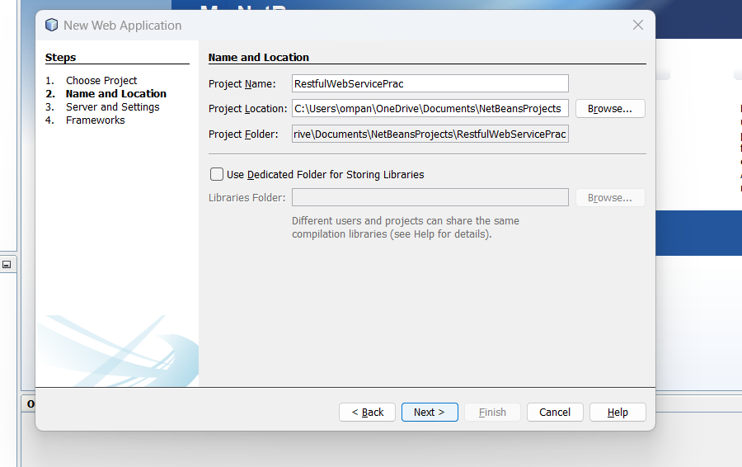

1. Select "JavaServer Faces" as the framework and "GlassFish" as the server. Click "Finish."

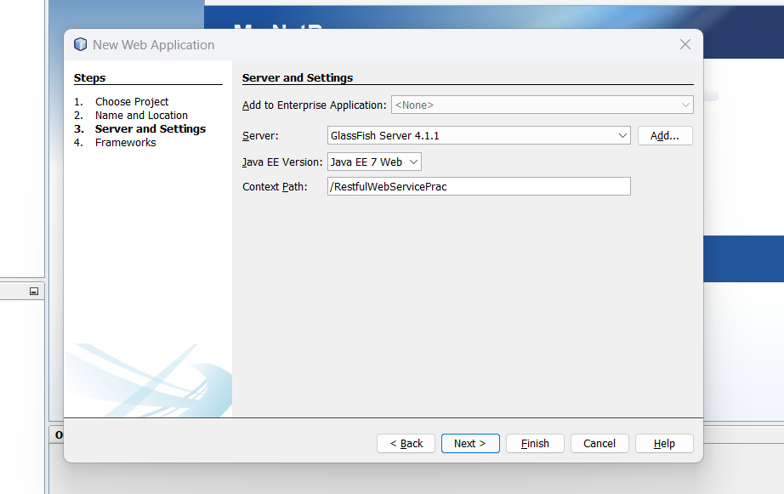

Step 2: Set Up the Database

Provide a Database name and valid username and password, and then create Database.

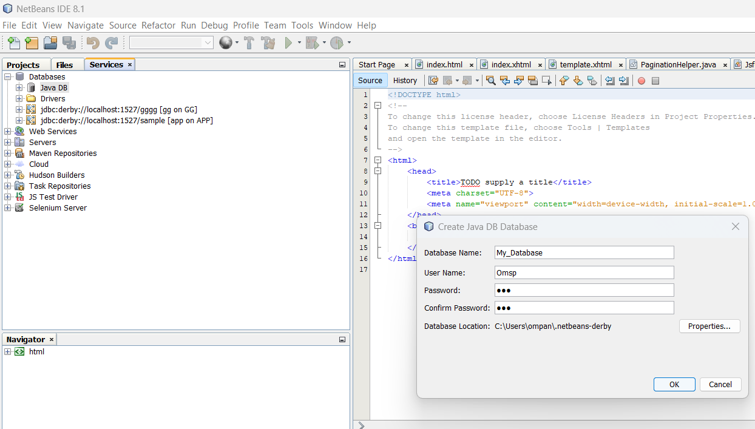

Step 3: Create table in My_Database

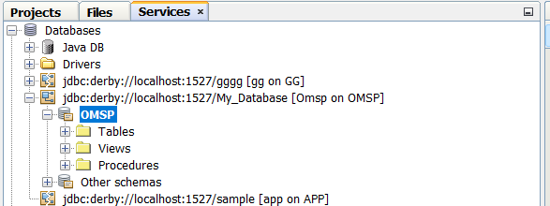

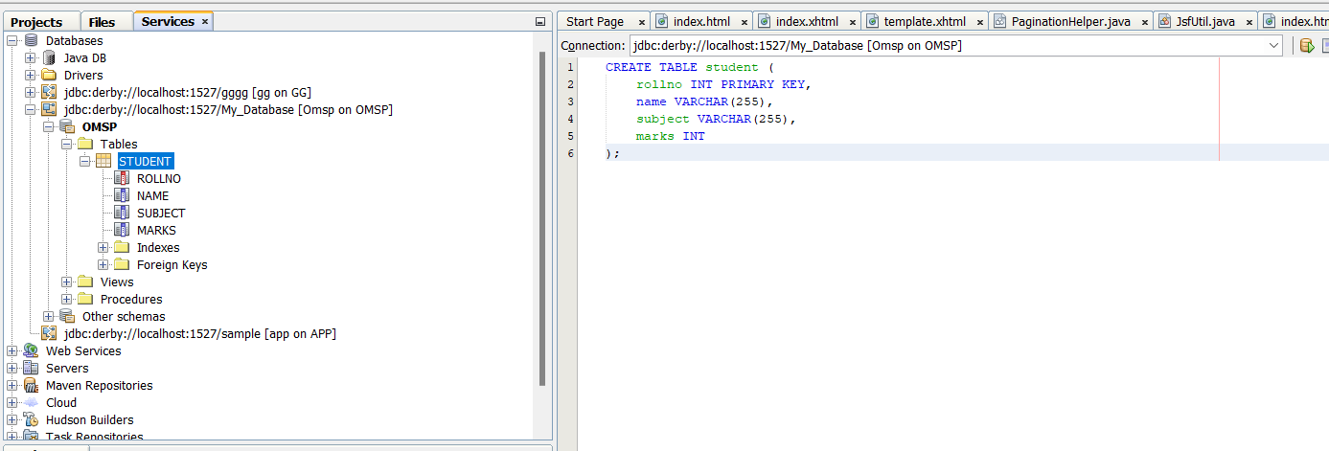

Step 4: 1. Under project name >new> Select RESTful Webservices from Database

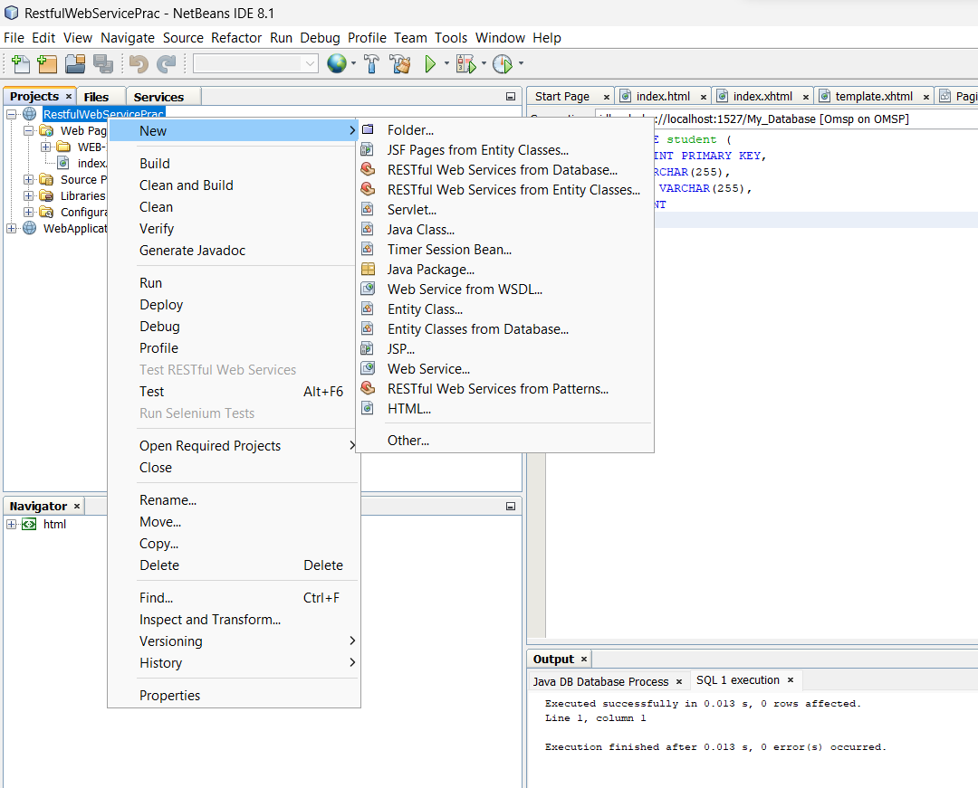

Step 5:

1. Select Data Source>New data source

2. 1. Under create data source, provide JNDI Name – Report

2. Selection connection

3.Add Table

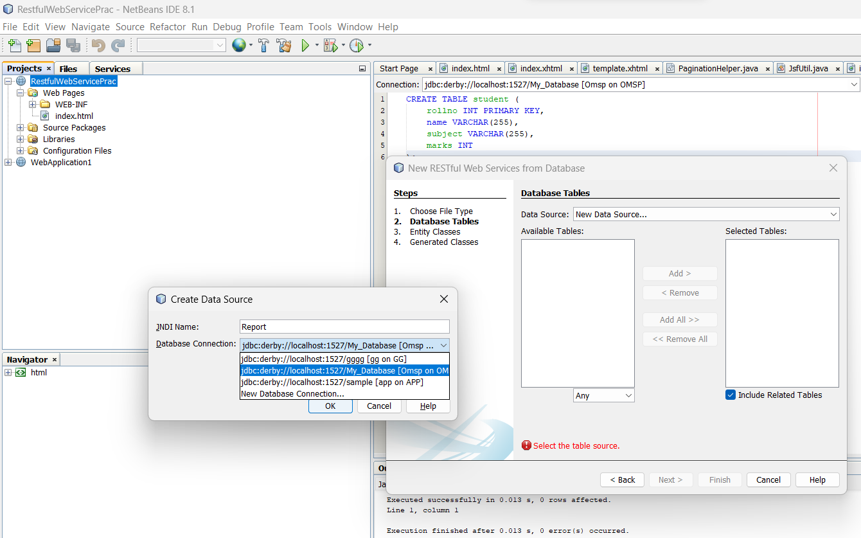

3.Add Table

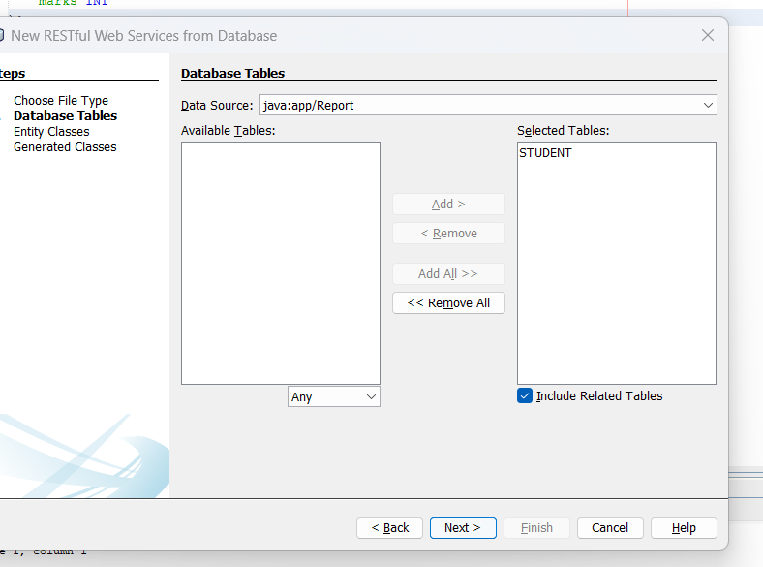

4.Enter valid a package name

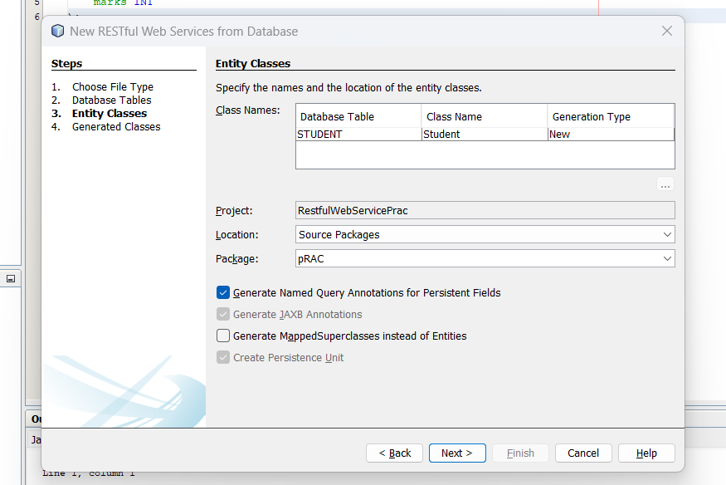

Step 6: Selection JSF pages from Entity class under Persistence , add your entity class

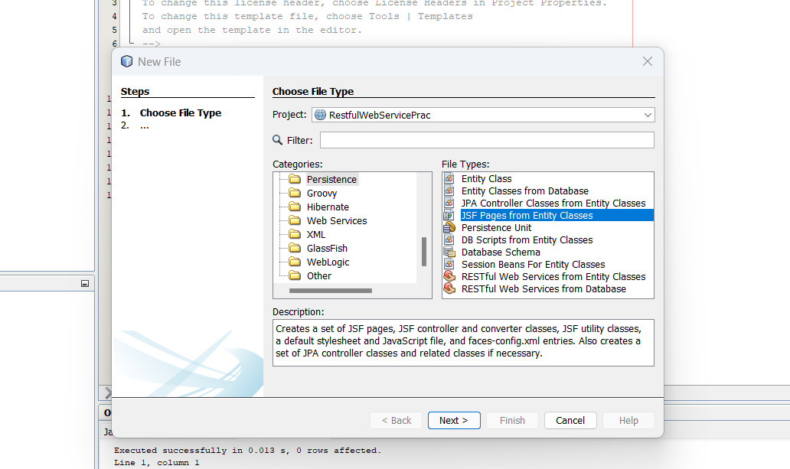

Step 7: Run the Application

